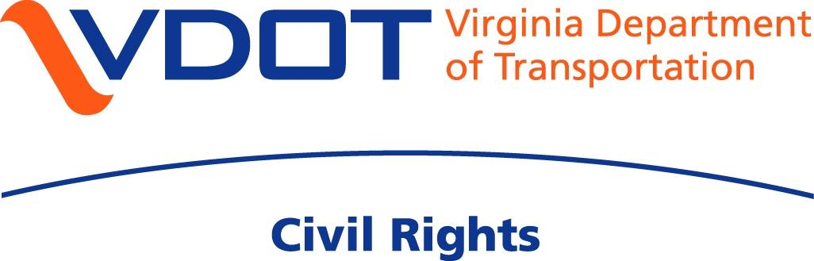

1401 E. Broad Street, Richmond, VA 23219

804.786.2085 Tel

800.508.3737 Toll Free

Form for Complaints Alleging Violations of

Title VI of the Civil Rights Act of 1964

Title VI of the 1964 Civil Rights Act requires that “No person in the United States shall, on the ground of race, color, or national origin, be excluded from participation in, be denied the benefits of, or be subjected to discrimination under any program or activity receiving federal financial assistance.”

The following information is necessary to assist us in processing your complaint. Should you require any assistance in completing this form, please let us know.

Complete and return this form to the Civil Rights Division: Ms. Sandra D. Norman, Civil Rights Division Administrator, Virginia Department of Transportation, 1401 E. Broad Street, Richmond, VA 23219.

**Section I**

I believe that I have been (or someone else has been) discriminated against on the basis of:

Race  
Color  
National Origin

What date did the alleged discrimination take place? 

**Section II**

First Name:   Last Name:  

E-mail Address: 

Postal Address:



City, State, Zip:



Telephone No.:

Home   Cell: 

Business: 

**Section III**

Are you filing this complaint on your own behalf?   
Yes No

If not, please supply the name and relationship of the person for whom you are complaining:   


Please explain why you have filed for a third party:

Please confirm that you have obtained the permission of the aggrieved party if you are filing on behalf of a third party:   
Yes No

Are you represented by legal counsel for this matter?   
Yes No

If yes, please supply name and contact information:

Have you previously filed a civil rights complaint with FHWA?   
Yes No

**Section IV**

Names of specific persons, Agency or public entity alleged to have discriminated

**Section V**

Have you filed this complaint with any of the following agencies?   
U.S. Department of Justice  
U.S. Department of Transportation  
Federal Highway Administration (FHWA)   
Other: 

Have you filed a lawsuit regarding this complaint?   
Yes No  
If yes, please provide the case number: 

**Section VI**

Please Include Details of Your Complaint Below. FHWA will contact you to request any additional documentation you may want to submit on behalf of your complaint.

**Important:** We cannot accept your complaint without a signature, please submit this form with a signature.

_____________________________ ______________________

Complainant’s Signature Date